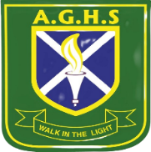
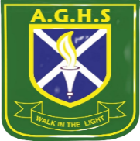
ALLIANCE GIRLS 2025 PREDICTION
POSSIBLE KCSE EXAM
121/1
MATHEMATICS
PAPER 1
TIME: 2½ HOURS

NAME……………………………………………………………………………………….
SCHOOL……………………………………………… SIGN………………………..
INDEX NO……………………………………………. ADM NO……………………

Kenya Certificate of Secondary Education.

INSTRUCTIONS TO CANDIDATES.
1) Write your name and index number in the spaces provided above.
2) Sign and write the date of examination in the spaces provided above.
3) Answer ALL questions in section A and B.
4) All your workings must be clearly shown as must be awarded for correct working even if the answer is wrong.
5) Non programmable silent scientific calculators and KNEC mathematical tables may be used.
FOR EXAMINERS’S USE ONLY
Section 1
Question | 1 | 2 | 3 | 4 | 5 | 6 | 7 | 8 | 9 | 10 | 11 | 12 | 13 | 14 | 15 | 16 | Total
Marks
Section 1I GRAND TOTAL
Question | 17 | 18 | 19 | 20 | 21 | 22 | 13 | 24 | Total
Marks

SECTION A ( 50 MARKS)
- Evaluate (3mks)

- A fruit juice dealer sell the juice in packet of 300ml, 500ml and 750ml. find the size of the smallest container that can fill each of the packets and leave a remainder of 200ml. (3mks)

- Without using table or calculators, evaluate (3mks)

- Simplify the following quadratic expression. (3mks)

- In a fundraising committee of 45 people, the ratio of men to women is 7:2. Find the number of women required to join the existing committee so that the ratio of men to women is changed to 5: 4. (3mks)

- A student expanded ( x + y)² incorrectly as x ²+ y ² calculate the percentage error in the answer if x = 4 and y = 6 (3mks)

- The figure below shows a trough which is 40 cm wide at the top and 25 cm wide at the bottom. The
trough is 20cm deep and 4.5 m long. Calculate the capacity of the trough in litres. (3mks)

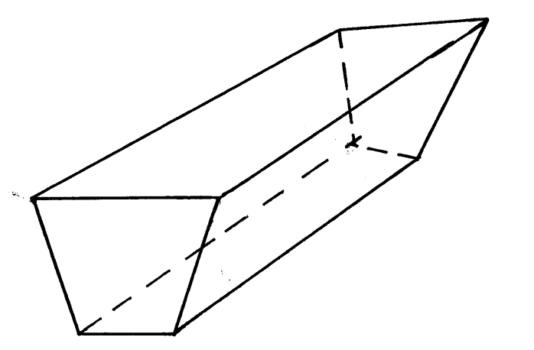

40 cm
4.5 m
25 cm

- Jemima’s team entered a contest where teams of students compete by answering questions that earn either 3 points of 5 points. Jemima’s team scored 44 points after answering 12 questions correctly. How many five-points questions did the team answer correctly. (3mks)

- Using compass and ruler only construct a triangle ABC such that AB= 6cm ,BC = 5cm and angle ABC = 67.5º measure the length of AC. (3mks)

10. Use table of reciprocals only to work out :$\frac{13}{0.156}− \frac{3}{0.6735}$ ( 3mks)

E
9cm
6cm
8cm
B
A
D
C

11. In the figure below, angle ABE is equal to angle ADC AE = 6cm, ED = 9cm and AB = 8cm,
calculate the length of BC. (3mks)
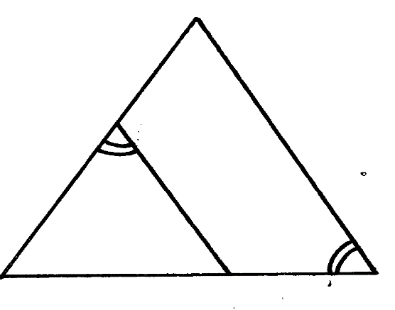

12. Simplify the expression below leaving your answer in rationalized surd form of a + b$\sqrt{c}$
$\frac{1+\tan{120^{o}}}{1+Cos 330^{o}}$ (4mks)

\

13. The two sides of a triangle are given 6 cm and 5 cm. the angle between them is 130º. calculate the area of the triangle ( giving your answer to 2 decimal places) (3mks)

14. Given that Km + hn = r and that m = $\left(\begin{aligned}−3 \\ −2\end{aligned}\right)$ n = $\left(\begin{aligned}0 \\ 4\end{aligned}\right)$ and r = $\left(\begin{aligned}−6 \\ 0\end{aligned}\right)$ . Find the scalars k and h (3mks)
~
~
~
~
~
~

15. A Kenyan bank buys and sells foreign currencies as shown.

Buying (Kshs.) Selling (Kshs.)
1 Euro 84.15 84.26
100 Japanese Yen 65.37 65.45

A Japanese travelling from France to Kenya had 5000 Euros. He converted all the 5000 Euros to Kenya shillings at the bank. While in Kenya, he spent a total of Kshs. 289,850 and then converted the remaining Kenya shilling to Japanese Yen. Calculate the amount in Japanese Yen that he received. (3mks)

16. The length of a rectangular mat is 1.5 m longer that its width, Find the length of the mat if its area is 6.5 m²( give your answer to 4 significant figures) (3mks)

SECTION II
Answer only five questions from this section
17. Five towns V,W,X,Y and Z are situated such that W is 200km east of V. X is 300km from W on a bearing of 150º. Y is 350km on a bearing of 240º from X. Z is 150º from V but 200º from X.
Draw the diagram representing the position of the towns. (use a scale of 1cm to represent 50km)
(5mks)

(b) From the diagram determine
(i) the distance in km of V from Z (1mk)
(ii) The bearing of Y from W ( 1mk)
(c) A plane heading to town X takes off from town Y and flies upwards at a constant angle which
is less than 90º. After flying a distance of 350km in the air it sees town X at an angle of depression of 50º. Calculate the distance of the plane from X at this point to the nearest km. (3mks)

18. Two circles of radii 3.5 and 4.2 cm with centres O₁ and O₂ respectively intersect at points A and B as shown in the figure below. The distance between the two centres is 6 cm.
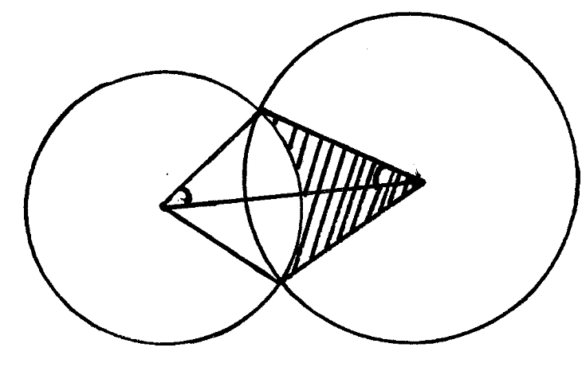
A
α
3.5 cm
4.2 cm
O₂
O₁

B
Calculate
- The size of AO₁B ( to the nearest degree) ( 3mks)

- The size of A O₂ B ( to the nearest degree) ( 3mks)

- The area of quadrilateral O₁AO₂B, correct to 2 decimal places. (2mks)

- The shaded area correct to 2 significant figures. ( take $π{22}/7$) ( 2mks)

19 (a) Complete the table below for the function y = 2 x ² + 4 X -3
X | -4 | -3 | -2 | -1 | 0 | 1 | 2
2x² | 32 |  | 8 | 2 | 0 | 2
4x-3 |  |  | -11 |  | -3
Y |  |  | -3 |  |  | 3 | 13
(b) Draw the graph of the function y = 2x² + 4x – 3 on the grid provided. (3mks)

(c) Use your graph to estimate the roots of the equation 2x² + 4x – 3 = 0 (1mk)

- Use your graph to obtain the roots of the equation 2x² + x – 5 = 0 to 1 decimal place. (3mks)

- Draw the line of symmetry to pass through the turning point of this curve. (1mk)

Age x years | 0≤ x < 5 | 5≤ x < 15 | 15≤ x < 25 | 25≤ x < 45 | 45≤ x < 75
Number of patients | 14 | 41 | 59 | 70 | 15

20. The table below shows patients who attend a clinic in one week and were grouped by age as shown in the table below.
- Estimate the mean age (4mks)

- On the grid provided draw a histogram to represent the distribution. (3mks)
Use the scales: 1cm to represent 5 units on the horizontal axis 2 cm to represent 5 units on the
vertical axis.

- (i) State the group in which the median mark lies ( 1mk)

(ii) A vertical line drawn through the median mark divides the total area of the histogram into
two equal. Using this information estimate the median mark. (2mks)

21. (a) Show by shading the unwanted region, the region which satisfies the following inequalities (8mks)
y> -3
4y ≤5x + 20
2y < - 5 x + 10
4y≤ - 3x – 12

(b) Calculate the area of this region in a square units (2mks)

22. The figure below (not drawn to scale) shows a quadrilateral ABCD inscribed in a circle. AB = 5cm, BC = 8cm,CD = 7cm and AD = 8cm. AC is one of the diagonals of length 10cm.
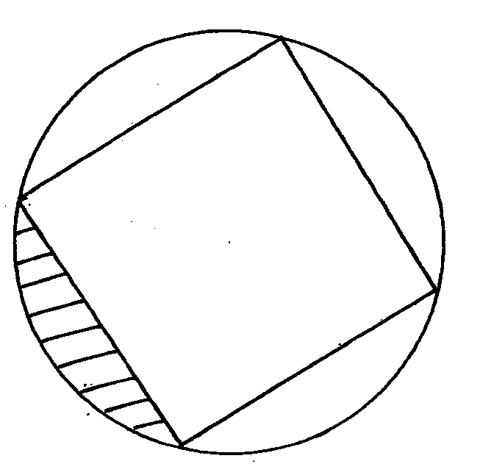
8cm
D
C

B
A
5cm
7cm
8cm

- Find the size of angle ABC. (3mks)

- Find the radius of the circle. (2mks)

- Hence, calculate the area of the shaded region. (5mks)

23. The diagram shows a frustum ABCDEF GH formed from a smaller pyramid ABCDO. The base the top of the frustums are squares of sides 12cm and 5 cm respectively. If Ob = 6cm and each of the slant edges of the frustum is 15 cm long. Calculate to 1 decimal place:
(a) the height OY of the small pyramid (3mks)
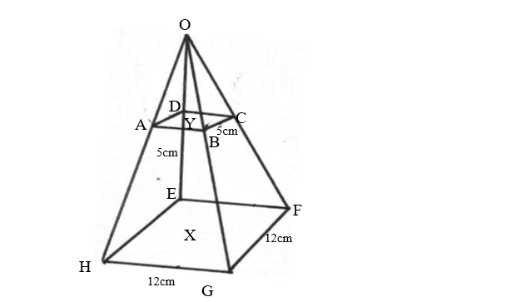

(b) the vertical height X Y of the frustum ( 4mks)

(c) the volume of the frustum (3mks)

24. The table below shows the income tax rates
Total income per month Rate in shillings per pound
In Kenya Pounds
1 - 325 2
326 - 650 3
651 - 975 4
976 - 1300 5
1301 and above 7

Mr. Musango earned a basic salary of shs. x and a house allowance of shs. 3000 per month. He claimed a tax relief for a married person of shs. 455 month. He paid shs. 1794 income tax per month.
- Calculate Mr. Musango’s basic salary in shs. per month (6mks)

- Apart from the income tax, the following monthly deductions are made. Service charge – shs. 100, health insurance fund – shs 280 and 2% of his basic salary as widow and children pension scheme.

Calculate:

- The total monthly deductions (2mks)

- Mr. Musango’s net income p.m (2mks)

